Light - 04
CLASS 08 - SCIENCE

 | Section A
1 | The objects which partially allow the light to pass through it are called  a) transparent  b) opaque  c) luminous  d) translucent | [1]
2 | If angle of incidence of ray of light on a plane mirror is 30° then angle of reflection is ________.  a) 45$​^{o}$  b) 60$​^{o}$  c) 90$​^{o}$  d) 30$​^{o}$ | [1]
3 | What is the function of Iris in human eye?  a) To return the coming light to the eye  b) To send the photo to the image lens  c) To control or regulate the amount of coming light to the eye  d) To receive the photo to the image lens | [1]
4 | Which one of the following case (s) is/are possible for convex lens? 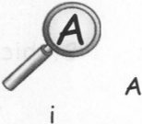  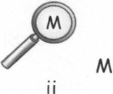  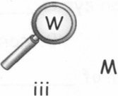  a) i and ii  b) ii and iii  c) only i  d) iand iii | [1]
5 | Radius of curvature of a concave mirror is 8 cm. What is the focal length of the concave mirror?  a) 20 cm  b) 4 cm  c) 16 cm  d) 8 cm | [1]
6 | Which mirror always forms virtual, erect, and image of the same size. The image is laterally inverted too.  a) Concave mirror  b) Plane mirror  c) Biconcave mirror  d) Convex mirror | [1]
7 | A person want to obtain virtual image of same size, he should use a  a) Concave mirror  b) Any of these  c) Plane mirror  d) Convex mirror | [1]
8 | Rainbow is formed due to  a) Refraction of light through air  b) Dispersion of light by water droplets  c) Reflection of lightning by water droplets  d) dispersion of light in vaccum | [1]
9 | When all the colours of white light are reflected back from an object, then object will appear  a) white  b) green  c) blue  d) black | [1]
10 | After looking sun the colour of other things appears  a) black  b) white  c) yellow  d) red | [1]
11 | Speed of light  a) Changes with medium  b) Remain same in all medium  c) Decrease in rarer medium  d) Increase in denser medium | [1]
12 | Which of the following works on the concept of multiple reflections?  a) Kaleidoscope  b) Binoculars  c) Telescope  d) Sunglasses | [1]
13 | Number of image formed of an object placed between the two inclined plane mirror at an angle of 90$​^{o}$ , is  a) 4  b) 3  c) 5  d) 2 | [1]
14 | The object which emits their own light are called  a) Non - luminous bodies  b) Burning objects  c) Luminous bodies  d) Light emitting objects | [1]
15 | White light is composed of:  a) Three colours  b) Seven colours  c) Five colours  d) Eight colours | [1]
16 | Part of the eye which controls the light entering is called  a) cornea  b) retina  c) lens  d) iris | [1]
17 | Due to which property of light sharp shadows of opaque objects are obtained?  a) Light travels in vacuum  b) Light travels in straight line  c) None of these  d) Light travels in zig - zag | [1]
18 | The image formed on cinema screen is an example of  a) Virtual image  b) Real diminished image  c) Erect image  d) Real image | [1]
19 | We can see an object when it  a) Has shining surface  b) Has bright colour  c) Refract or absorb the rays of light  d) Reflect or emit rays of light | [1]
20 | A magnifying lens is a ________ lens.  a) Diverging  b) Plane  c) Concave  d) Converging | [1]
21 | The perpendicular to the reflecting surface is called________.  a) Reflected rays  b) Normal  c) Incident rays  d) Refracted rays | [1]
22 | From which one of the following you will always get a virtual, erect and of the same size as object image?  a) Concave lens  b) Concave mirror  c) Plane mirror  d) Convex mirror | [1]
23 | The colour of eyes is due to colour of  a) Iris  b) Eye lens  c) Retina  d) Cornea | [1]
24 | Sky appear blue coloured during day because  a) Sun light is made up of blue light only  b) Blue colour of light is visible in sunlight only  c) Sky is blue in colour  d) Blue coloured light can be scattered by small particles | [1]
25 | The lens present in the human eye is made up of:  a) White rubber  b) Transparent protein  c) Plastic  d) Glass | [1]
26 | Different colours are due to ability of the object to  a) Absorbs the rays of light  b) Bend the rays of light  c) Reflect the rays of light  d) Divert the rays of light | [1]
 | Section B
27 | Explain the incident ray, point of incidence and normal at the point of incidence in brief. | [2]
28 | How many types of non - optical aids for visually challenged persons are used? | [2]
29 | Eyes of the nocturnal birds have large cornea and a large pupil. How does this structure help them? | [2]
30 | How many times is a ray of light reflected by two plane mirrors placed parallel and facing each other? | [2]
31 | Movies that we see are separate pictures but we see a moving picture. How? | [2]
32 | What is the Braille system? | [2]
33 | Write the laws of reflection. | [2]
34 | Mention against each of the following whether regular or diffused reflection will take place when a beam of light strikes. Justify your answer in each case.(a) Polished wooden table (b) Chalk powder (c) Cardboard surface (d) Marble floor with water spread over it. (e) Mirror (f) Piece of paper | [2]
35 | What kind of lens is there in our eyes? Where does it form the image of an object? | [2]
36 | Why one should include the vitamin A rich eatables in their diet? What are the main source of vitamin A? | [2]
37 | Do we see all objects due to reflected light? | [2]
38 | (1) The objects which emit the light is called __________objects. (2) Plane mirror forms only a __________ image of an object. (3) When two mirrors are set parallel to each other then they form ____________ images of an object. | [2]
39 | Suppose you are in a dark room. Can you see objects in the room? Can you see objects outside the room. Explain. | [2]
40 | Two mirrors meet at right angles. A ray of light is incident on one at an angle of 30° as shown in fig. Draw the reflected ray from the second mirror. 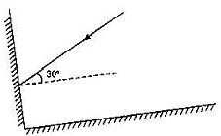 | [2]
41 | Describe the construction of a kaleidoscope. | [2]
42 | Draw a labeled sketch of the human eye. | [2]
43 | Explain the function of muscles attached to the lensof the eye. | [2]
44 | Which part of the eye gets affected if someone is suffering from cataract? How is it treated? | [2]
45 | What are the characteristics of image formed by plane mirror? | [2]
46 | What is the angle of incidence of a ray if the reflected ray is at an angle of 90° to the incident ray? | [2]
47 | What happens to light when it gets dispersed? Give an example. | [2]
48 | Define Lateral Inversion. | [2]
49 | Look at the figure. Can the image of the child in it be obtained on a screen? 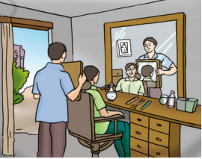 | [2]
50 | The angle between incident ray and reflected ray is 60°. What is the value of angle of incidence? | [2]
51 | Here are given capital letters of the English Alphabet encircle the letters which will not show lateral inversion on facing a plane mirror. 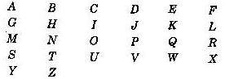 | [2]
52 | Gurmit wanted to perform Activity 13.8 using a laser torch. Her teacher advised her not to do so. Can you explain the basis of the teacher’s advise? | [2]
53 | How many kinds of nerve endings are found is human eye? What are their functions? | [2]
54 | Draw a ray diagram to explain the formation of a virtual image in a plane mirror.  - of a pencil  - of a point | [2]
55 | How does a night bird see the object? What is the difference in the structure of the eyes of night bird and day light birds? | [2]
56 | The distance between the object and its image formed by a plane mirror appears to be 24 cm. What is the distance between the mirror and the object? | [2]
57 | Match the items given in Column I with one or more items of Column II. 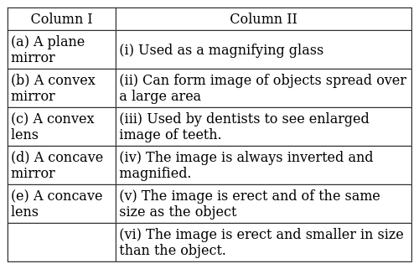 | [2]
58 | Boojho stands at A just on the side of a plane mirror as shown in figure. Can he see himself in the mirror? Also can he see the image of objects situated at P, Q and R? 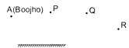 | [2]
59 | State the laws of reflection. | [2]
60 | Figure shows the word REST written in two ways in front of a mirror. Show how the word would appear in the mirror. 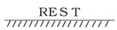  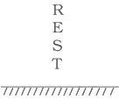 | [3]
61 | What is Braille system? Explain. | [3]
62 | Differentiate between regular and diffused reflection. Does diffused reflection mean the failure of the laws of reflection? | [3]
63 | Mention whether diffused or regular reflection will take place when:  - A beam of light strikes a mirror.  - A beam of light strikes a cardboard surface.  - A beam of light strikes a piece of paper. | [3]
64 | Explain how you can take care of your eyes. | [3]
65 | What is the first and second law of reflection? | [3]
66 | A shiny metal forms an image, but image is not as clear as that is formed by plane mirror. Why? | [3]
67 | How many plane mirror strips are there in kaleidoscope? How are they arranged? State one use of kaleidoscope. | [3]
68 | Write the differentiate between Luminous and Non Luminous objects. | [3]
69 | Define the following with diagram:  - Angle of incidence  - Angle of reflection. | [3]
70 | State three uses of a plane mirror. | [3]
71 | Write down the names of parts of the eye in the blank spaces shown in the figure. 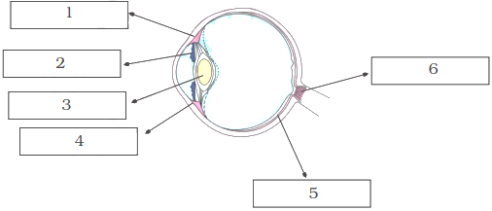 | [3]
72 | There is a mistake in each of the following ray diagrams given as a figure a, b, and c. Make the necessary correction (s).  - 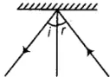  - 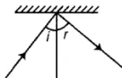  - 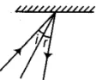 | [3]
73 | How we can see non - luminous object? | [3]
74 | Describe an activity to show that the incident ray, the reflected ray and the normal at the point of incidence lie in the same plane. | [3]
75 | What is reflection of light? State the laws of reflection. | [3]

